**//Om Shree Gurubhyo Namaha//**

**VARICOSE VEINS DIAGNOSIS**

***- R. Subha Lekha***

*and happy life, free from sorrow and sufferings caused by diseases or accidents. 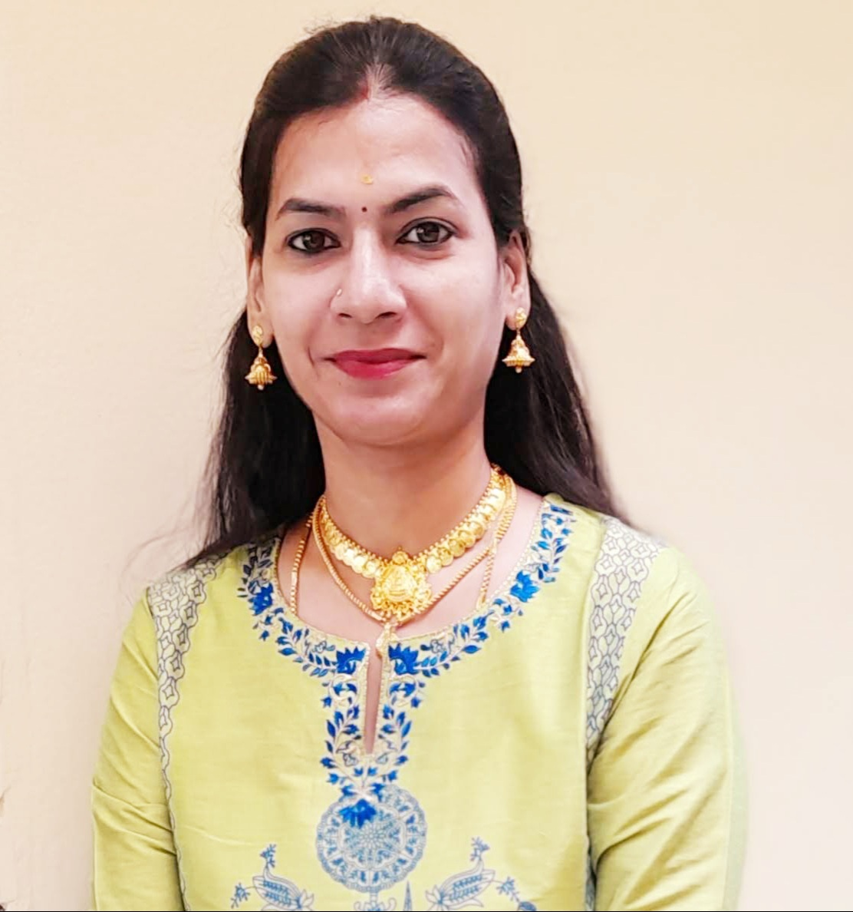R.Subha Lekha is a Research Scholar of JKR Astro Research Foundation. She pursued her Masters in Vedanga Jyotisha holding First Rank from Yoga Samskrutham University, Florida USA. Presently she is pursuing her PhD in Medical Astrology under the guidance of Dr. N.V.R.A. Raja sir. She is by profession Astro Consultant.*

*I am glad that I have got an opportunity to write an article about Varicose Veins applying Kalamsa rule.* *Medical astrology is a science that demands a union of knowledge of both astrology and medicine. Ideally, it takes years of acquiring astrological expertise and then becoming totally familiar with physiology and anatomy to qualify as a medical astrologer who with the cooperation of physician can accurately diagnose diseases and advise clients on the best procedures for regaining health. A horoscope indicates good, bad and indifferent conditions in nature and cosmos at the moment of birth of a native. By proper delineation of the horoscope, one can find out good, bad or indifferent traits and characteristics of the native and also these parameters of nature.*

Medical astrology can be a lifetime guide for timely preparation for a healthy and happy life, free from sorrow and sufferings caused by diseases or accidents.

Medical astrology is very important science. Astrologers have been predicting diseases through various combinations in the horoscope. “I believe that astrology and complementary medicine will help take the huge pressure off doctors. Medical astrology is useful diagnostic tool which enables us to see strengths and weaknesses via the birth chart. Astrology offers self-understanding to people. People who oppose what I say are usually bullies who never studied astrology. Astrology was until modern times, a part of the tradition of medicine.”

An attempt has been made to diagnose the disease astrologically through divisional charts. The approach is to pinpoint the location and type of disease. This have been applied and tested on hundreds of horoscopes with high accuracy.

Varicose veins are swollen, twisted blood vessels that bulge just under your skin’s surface. These blue or purple bulges usually appear in your legs, feet and ankles. They can be painful or itchy. Spider veins, which may surround varicose veins, are smaller red or purple lines that appear close to your skin’s surface.

Although they can be unsightly and uncomfortable, varicose veins aren’t dangerous for most people. In some cases, severe varicose veins can lead to serious health problems, such as blood clots. You can relieve most varicose vein symptoms at home or your healthcare provider can treat them with injections, laser therapy or surgery.

Varicose veins and spider veins are both types of [venous disease](https://my.clevelandclinic.org/health/diseases/16754-venous-disease), but they look different. Spider veins are smaller and thinner than varicose veins. They look like red or blue spider webs or branches of a tree, and they are close to the skin’s surface.

Spider veins aren’t usually painful. They can appear anywhere on your body, most often behind your knee, on your feet or on your face. Varicose veins usually appear on your feet and legs. Varicose veins are very common. Around 1/3 of all adults have varicose veins. They are more common in people assigned female at birth than in people assigned male at birth.

In this research work, an attempt was made to apply the theory of concept linking the Karaka planets and its **Kalamsa Lords** to Vimsoththari Dasa system to arrive at the timing of events of a bhava or karaka as advocated by **Meena 2 Jr. my Guruji Naadi Jyotisha Kesari Dr. NVRA Raja garu**. I have applied the Kalamsa principles by using the stellar dispositor theory advocated by Meena 2 Naadi and observed that almost all the major events of a native have connection with Kalamsa Lords at the time of fructification of event and also they have connection with Dasa, Bhukti and Antara lords in Gochara/transit.

**CHART NO.1**

**D.OB :- 17.12.1958 T.O.B:- 20:00 P.O.B :- Vizianagaram, A.P.**

|  |  |  |  |
| --- | --- | --- | --- |
| **KE** | **(MA)** |  |  |
| **MO** | **NATAL CHART** | | **ASC** |
|  |  |
| **VE, SA, SU** | **(ME)** | **JU** | **RA** |

|  |  |  |
| --- | --- | --- |
| **PLANET** | **STAR** | **PADA** |
| ASC | Pushyami | 2 |
| SUN | Moola | 1 |
| MOON | Purvabhadra | 3 |
| MARS | Bharani | 4 |
| MERCURY | Anuradha | 4 |
| JUPITER | Visakha | 3 |
| VENUS | Moola | 4 |
| SATURN | Moola | 2 |
| RAHU | Chitha | 1 |
| KETU | Revathi | 3 |



**KL- Kalamsa Lord, KLGU-Kalamsa Lord Guna,KLJP-Kalamsa Lord Jeeva Planet, KLSP-Kalamsa Lord Sareera Planet**

**Principle for consideration:**

* Saturn, the main karaka for Varicose Veins and (or) its Kalamsa lord has anyway connections with **Jupiter**, **Mars**, **Rahu** and **Ketu** along with 6,8,12 houses or its house lords, then the chances are bright.

**ANALYSIS**

* **Lagna lord Moon** is posited in 8th house of sudden events. Moon represents the parts alimentary canal, water in body, lymph. Moon is in the star of Jupiter who happens to be the 6th lord.
* **Lagnapadadipathi and 8th lord Saturn** is in 6th house. Saturn represents the parts of the body are Legs, Joint bones, Limbs, knees etc. Diseases it causes damage and loss of limbs, bone fracture, rheumatic pains, **varicose veins**, etc.
* **6th Lord** **Jupiter** is in 4th H and is in its own star. Jupiter represents the body parts thigh, hip region, fat, lungs, karaka for expansion, obesity.
* **12th Lord Mercury** is in 5th house and is in retro. Mercury is in the star of Saturn who happens to be the 8th lord and karaka for Varicose. Mercury represents the body parts skin, veins.
* **Mars** karaka for blood, blood vessels is in its own house (Aries sign) in retro. Mars is in the star of Venus who happens to be the badakadipathi. Mars in retro give ketu results. Ketu is in natural 12th house.
* **Rahu** will deliver the results of Sign lord - Mercury, Star lord - Mars, aspected by 8th lord Saturn (karaka for Varicose) and through bhinnapada gets conjunction with Jupiter the 6th lord. Rahu represent body parts feet, breathing, neck. Diseases it causes are disease in feets, poisoning, varicose veins, etc.
* **Ketu** will deliver the result of Sign lord – Jupiter, Star lord – Mercury, aspected by Jupiter through bhinnapada. Ketu represents the body parts belly, feet.

The native was diagnosed of VVD during **Venus Dasa – Jupiter Bhukti - Moon Antara**.

* **Dasa lord Venus,** the badakadipathi is posited in 6th house in the star of Ketu. Venus is conjuncted with 8th lord and marakadipati Saturn who is the karaka for Varicose. Venus and Jupiter (6th lord) are in **Sthoola Parivarthana**.
* **Bhukti lord Jupiter,** the 6th lord is in 4th H. Jupiter is in its own star of Visakha. Jupiter aspects directly Mars (natural 8th lord) and through bhinnapada gets aspected by Mars. Jupiter aspects Moon, the lagna lord and kalamsa lord of Saturn. And through bhinnapada aspects lagna.
* **Antara lord Moon,** who happens to be the kalamsa lord of Saturn is along with Venus (Dasadipati) and Sun (Marakadipati). Moon is in the star of Jupiter who happens to be the 6th lord (bhukti nada). Moon is aspected by Jupiter. Moon through bhinnapada gets connection with natural 12th house and conjuncts with Ketu who happens to be the star lord of karaka Saturn, Venus (badakadipati) and Sun (marakadipati).

**As per our Pujya Guruji Shri N. V. Raghavacharya,**

**“Dasanatha will give the results of its star lord and connections. Bhuktinatha will give the results of its starlord and connections.”**

* **Saturn,** karaka for VVD and lord of 8th house is in 6th house of roga aarambha. Saturn is in Ketu star (represents feet). Saturn aspects its kalamsa lord Moon and Rahu (one of the karaka for Varicose; sanivath rahu). Saturn is in conjunction with both marakadipati (Sun) and badakadipati (Venus).

**CONCLUSION**

Hence, it is to be seen in the above chart, Saturn the karaka for VVD who happens to be the 8th lord is getting connections with marakadipati, badakadipati, posited in 6th house, and is the starlord of 12th lord Mercury. Moon the Kalamsa lord of Saturn is aspected by karaka Saturn and 6th lord Jupiter. All these indicated the arouse of Varicose veins disease to the native.

**Jai Meena2**

Ref: Practical Stellar Astrology-By Guruji Sri NV Raghava Chary (Meena2)

Stellar Effects in Astrology-Kalamsa Gunas-By Dr.NVRA Raja Meena2 Jr.

Stellar Effects in Astrology-Jeeva and Sareera By Dr.NVRA Raja Meena2Jr.

Class Lectures of JKR Astro Research Foundation,Secunderabad